**Basic algorithm design decisions**

In relation to team’s goal/problem number one:

“The task is to develop algorithms to help improve efficiency like when how much coins each user should get for certain task related to exercise done or their target goals achieved according to their training exercise plan or workout. “

The problem which can be extracted from this is how much incentives should be given in relation to a specific exercise. For starters, main aim of exercises can be labelled in the following, health (which includes losses of weight and increase in muscle/special conditions), body shape/type and self-discipline /metal benefits. If we look into the specifics, measuring the progress of health and body shape related exercises can be all use one factor, which is calories burned. Therefore, building a model predicts number of calories burnt in a certain activity can help indicting the progress made and give out incentives accordingly. Because each activity has different rates in which calories are burnt (due to many different factors such as heart rate, intenseness, time, body temperature, environment… etc) for example running will increase more in heart rate in comparison with walking or juggling. Therefore, for a start, I will look into only one activity at a time and have chosen walking, measured by steps taken vs calories burnt on a daily basis.

**Solution design:**

* *Research datasets includes calories burnt and steps taken.*
* *Building a model which can be used to predict calories burned when inputs steps taken.*
* *Calculate individual’s calories spend daily to compare the differences with exercises (using BMR).*
* *Consider individual’s personal body condition using BMI.*

One data-set was found and cleaned, which include many attributes such as hours of sleep, mood…etc. but I will only consider calories_ burned and step_count.

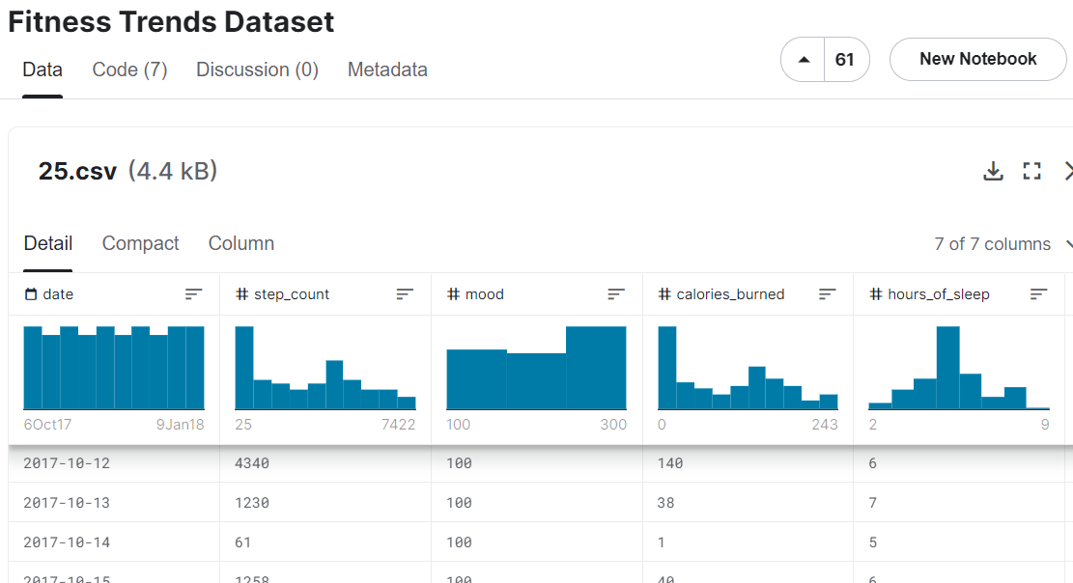

(full data-set can be find on MS team’s- link provided as well in case of updates-last reviewed on 28th of April 2022)

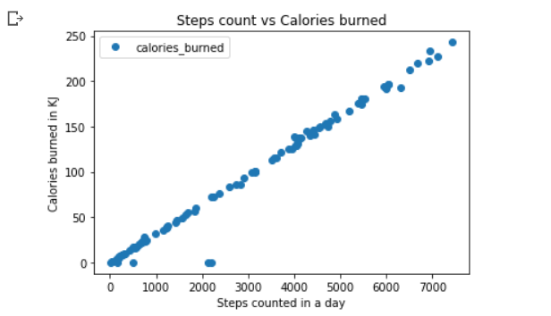After producing a visual of scatter plot, it is obvious this is a linear regression with strong positive relation. In this case calculate Pearson Correlation to support my initial hypothesis (more steps taken in a continuous manner will result in higher calories burnt). The result is Pearson correlation = 0.9892597.

After building and training the model using Python libraries, the resulting outputs (tests) have a maximum difference of + - 5 calories (KJ) excluding data outside the training rage (step numbers like 0 will not work with the current model).

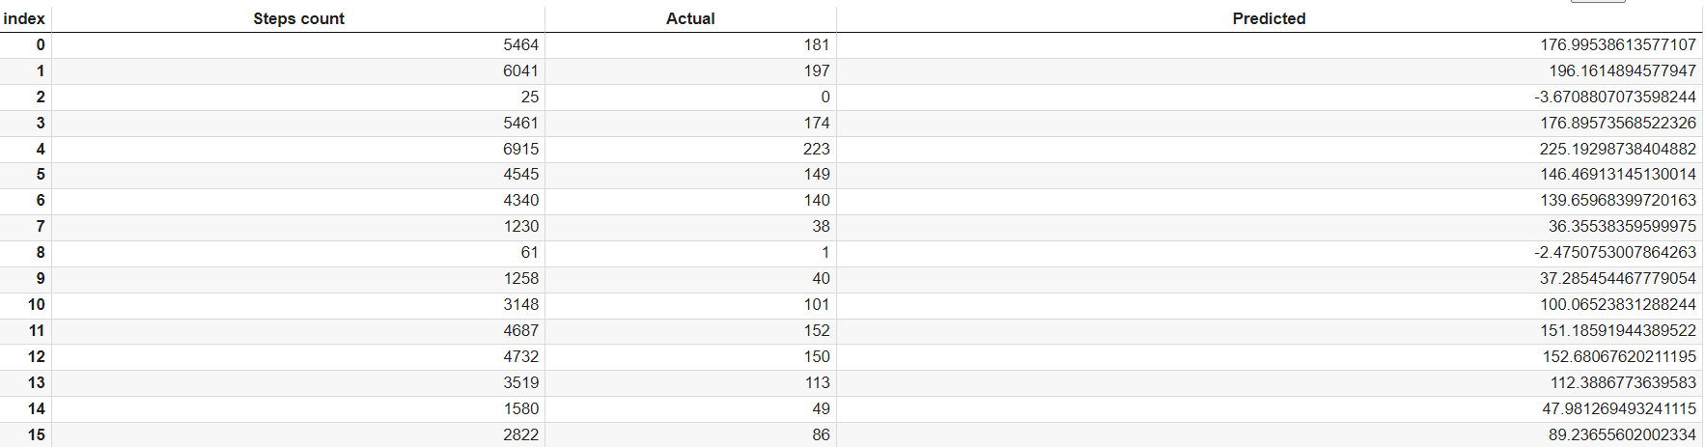

(more detailed tables and graphs can be find on MS team’s channel)

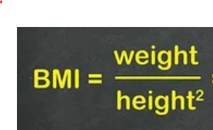**BMI and BMR calculator:**

BMI is the index of body mass which is the ratio of body tissues, the simplest calculation is

This will give us a basic understanding if the individual is healthy or not (either obssed or slim or normal), the programm can adjust difficulties of the acitvity and level of incentives accordingly.

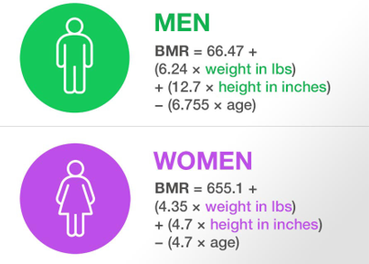 BMR is the amount of calories spent daily for an individual when at rest. BMR can be used to compare participant’s activity level by taking away BMR from calories burned predicted. The calculation of BMR is:

(In the actual calculation, centimetres are used instead of inches)